Profile

- Dr. R.Ranganatha | 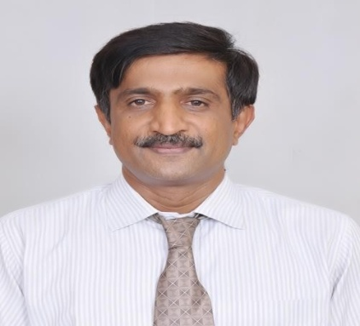
- Professor
- Working at SJCIT since 17th May 1999
- Phone: 98453 12626
- Email Id:
rrmedsjcit@gmail.com
ranganathsjcit@yahoo.co.in

Academic Qualifications:
Qualifications | Board / University | Institute and place | Year of passing
B.E. | Bangalore University | M.S.R.I.T., Bangalore | July 1991
M.E. | Bangalore University | UVCE, Bangalore | February  1995
Ph.D | Bangalore University | UVCE, Bangalore | June 2014
Experience:

Organization | Designation | Period
S.J.C. Institute of Technology | Professor | May 1999 - Present
M/S. Rapsri Engineering Industries Limited, Bangalore | Assistant Manager | April 1995 – May 1999
Dayananda Sagar Polytechnic | Lecturer | February 1992 – June 1992
M/S. Meenakshi Steel Re- Rolling Private Limited, Bangalore | Trainee Engineer | October 1991 – January 1992
Summary | Teaching | Industry
27 years -Total | 22 years | 5 years

Specialization:
- Metal Casting Science, particularly specialized in Copper base alloy castings.
- Heat Treatment and Metallurgy
- Fluid Mechanics and Turbomachines

Subject Taught:

1.Material Science & Engineering | 10. Automotive Engineering
2. Applied Thermodynamics | 11. Industrial Management
3. Manufacturing Process | 12. Introduction to Computer Programming
4. Metrology and Measurements | 13. Advanced Material Technology
5. Fluid Mechanics | 14. Mechanics of Composite Materials
6. Fluid Machinery | 15. Non Destructive Testing
7. Turbo machines | 16.. Control Engineering
8. Mechatronics & Microprocessor | 17. Concurrent Engineering
9. Heat & Mass Transfer | 18. Software Engineering [ during 2002-2003]

Publication Details [Recent years)
Faculty Name. | Publication [National / International] | Published in/at | Publication Title | Year
R.Ranganatha et. al., | National | Aluminium in India | Retrogression and Re-aging heat treatment on the properties of high strength aluminium alloys | 2010
R.Ranganatha et. al., | Inter national | International Journal of Engineering & Technology | Retrogression and Re-Aging treatment of AA 7049 aluminium alloy | 2011
R.Ranganatha et. al., | Inter national | International Journal of Advanced Materials Science | A study on age hardening behavior of the high strength aluminium alloy | 2011
R.Ranganatha et. al., | Inter national | Transactions of Nonferrous Metals Society of China | Multi-stage heat treatment of aluminium alloy AA 7049 Citations: 57 | 2013
R.Ranganatha et. al., | International | International Journal of Engineering Research and Advanced Technology | Development and Implementation of Client-Server architecture for PLC based miniature bending machine | 2016
R.Ranganatha et. al., [Coauthor] | International | International Journal of Scientific research and development | Investigation on mechanical behavior of hybrid jute/sisal fiber reinforced polyester composites | 2017
R.Ranganatha et. al.,  [Coauthor] | International | Materials Performance and Characterization [ASTM] | Influence of RRA Treatment on Intergranular Corrosion Resistance and Exfoliation resistance in AA7010 Aluminium Alloy | 2021
R.Ranganatha et. al., | International | Material Science and Heat Treatment {Springer] | Effect of Retrogression and re-aging on tensile mechanical properties in transverse direction of extruded rods from aluminium alloy AA 7049 | 2021
R.Ranganatha et. al.,  [Coauthor] | International | Transactions of Indian Institute of Metals | Mechanical and Moisture absorption behavior of Alkali Treated Sida Acuta Composite | 2021

Important Paper presented in Conference

Name of the Faculty | Title of the workshop/Conference | Date and Venue
R.Ranganatha | International conference on Higher Education | Indian Institute of  Science, Bangalore, 12th -14th July 2007
R.Ranganatha et. al., | 48th Annual Technical Meeting and National Metallurgists Day (International  Conference),  Won II prize for best presentation | Indian Institute of Science, Bangalore,  14th -16th November 2010
R.Ranganatha et. al., | International Conference on World Class Materials & Manufacturing Technologies- M&MT 2011 | American Society of Metals, Mumbai, India, 8th – 10th March 2011
R.Ranganatha et. al., | International Conference on Strength of Materials-ICSMA 16 | Indian Institute of Science, Bangalore, 19th - 24th August 2012
R.Ranganatha et. al., | TMS 2015 (International Conference) | Florida, 15th March to 19th March 2015

Consultancy Activities:

Organization | Designation | Period
M/S. Mechelonic Weld Private Limited, | Foundry Consultant | June 2002 – Dec 2002
Centre for Continuing Education, Southern Region, Institute of Indian Foundry men | Resource Person | Dec 2003 – Dec 2004
The Institute of Indian Foundrymen,  Bangalore Chapter | Hon. Secretary  Vice Chairman  Chairman | April 2014 – April 2017  May 2017 – April 2018  May 2018 – April 2020

Student Projects Guided:
- Have guided about 25 B.E.(Mechanical Engineering) and 12 M.Tech student projects. Presently 3 M.Tech (Industrial Automation & Robotics & Mechanical Engineering) student projects are being guided.
- 2 Research Scholars are pursuing Ph.D degree

R & D Project
Sl No. | Name of the Faculty | Projects Title | Project Sanctioned | Status of the project
1` | R.Ranganatha | Development of Functionally graded material | Rs.50,000=00 | completed
2 | R.Ranganatha | Establishment of Stress Corrosion Cracking test set up | Rs.5,00,000=00 | completed
2 | R.Ranganatha | Corrosion testing of Aluminium alloys- consultancy services | Rs.1,50,000=00  earned so far | On going

Recognitions

1 | Certificate of Appreciation for the contribution to EMC Academic Alliance Program by EMC2 Limited, Bangalore | 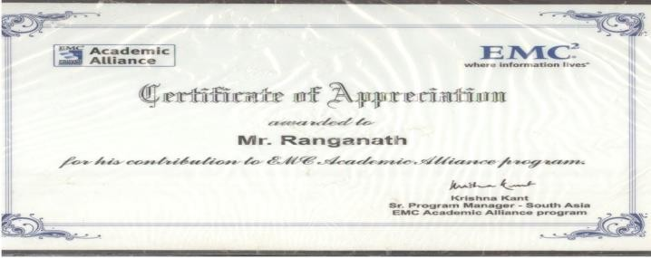
2 | Project Staff in developing India’s First Compulsator at Indian Institute of Science, Bangalore | 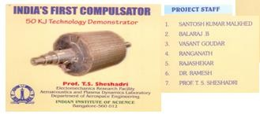
3 | Certificate of Appreciation for the development of Industrial and Automation Laboratory with a grant of Rs.20 lakhs worth Equipments | 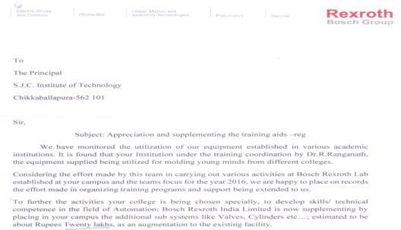

Additional responsibilities handled | 1. First member to introduce Industrial Visits and Technical Talks in relevance to  the subjects studied by the students at SJCIT
2. First faculty member to initiate Research and Development activities at
Mechanical Engineering by developing Centrifugal Castings Machine, Heat Treatment Furnace and setting up facilities to observe microstructure
3. Development of Procedural Manual for getting ISO 9001 certification and
mapping various activities to acquire accreditation by NBA.
4. Initiated and Established Placement and Training Centre at SJCIT
Since 1999 to 2010; worked as Placement Officer. More than 50 different companies had visited SJCIT for campus recruitment and about 1000 students have got employment in this tenure. About 7 MoU were established during tenure. The present complete Placement Facility was established by this
team.
 | 5. Established E.D.P. Cell
6. Since 2014; established technical consultancy services at MED. Presently, the consultancy services are provided to the following Industries.
M/S. Hindalco Limited, Mumbai
M/S. Rachamallu Forgings Private Limited, Hyderabad M/S. Vikram Sarabhai Space Centre, Trivandram
7. Design of Curriculum: Through consistent efforts, Dot Net Technologies, Object Oriented Analysis and Design, Storage Area Network, Hydraulics, Pneumatics and PLCS courses have become integral part of B.E. Mechanical
and Computer Science disciplines.

Membership of Professional Bodies:
- Fellow Member of Institution of Engineers, Kolkatta.
- Life Member of Indian School of Technical Education, New Delhi
- Member of Institute of Indian Foundry men, Kolkatta
- Member of Aluminium Association of India, Bangalore
- Member of Indian Institute of Metals, Bangalore
- Member of Bangalore Science Forum, Bangalore
- Member of Indian Society of Heating, Refrigeration and Air Conditioning, New Delhi
- Life member of Indian Society of Systems for Science and Technology

Books Authored:
Presently authoring a book on “Understanding Electrical Concepts through SME approach”; Status: The Manuscript is ready and it is undergoing corrections.

